Instructions for Meeting room booking sheet
Access
To access the system – go to the following URL:
http://cles-mrbs/bios

Log In
At this page type in your University Username & Password

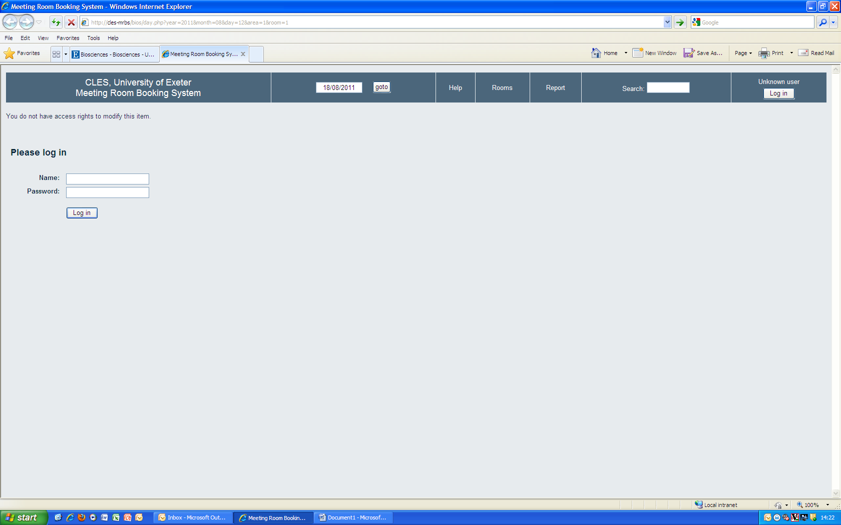

You will automatically be taken to the room booking page for today’s date.

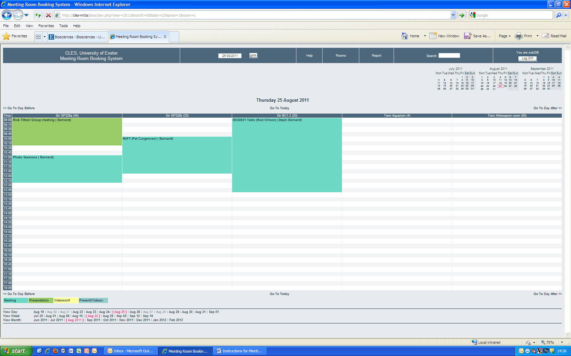

To make a room booking:

Select the date you wish to book by either clicking on the date at the top of the page which will drop down a calendar for you to select your date from,

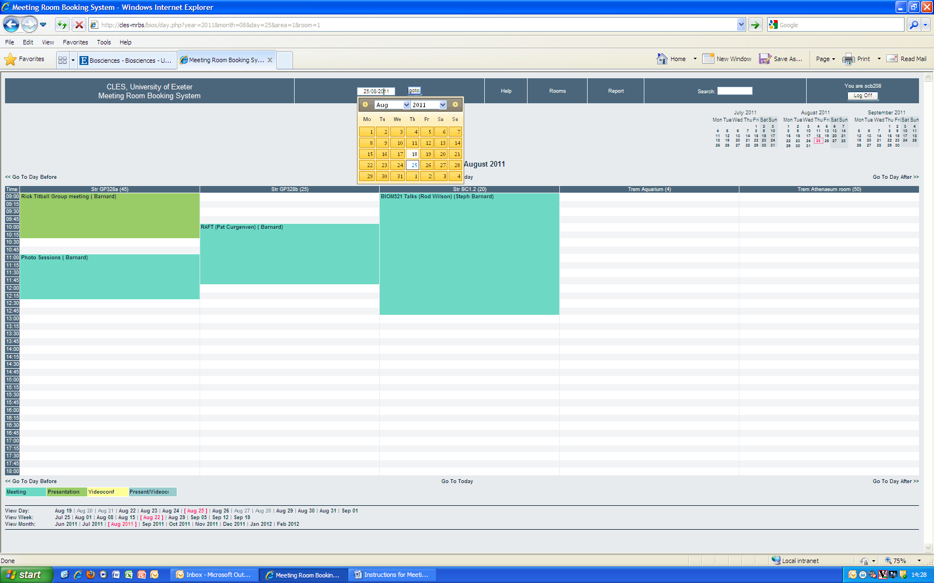

Or – click on a date on the calendar at the top right hand side of the page.

The rooms are listed across the page so you can easily see which ones are available on the date you require.

Once you have decided which room to book, click on the required start time of your meeting and the following page will appear:
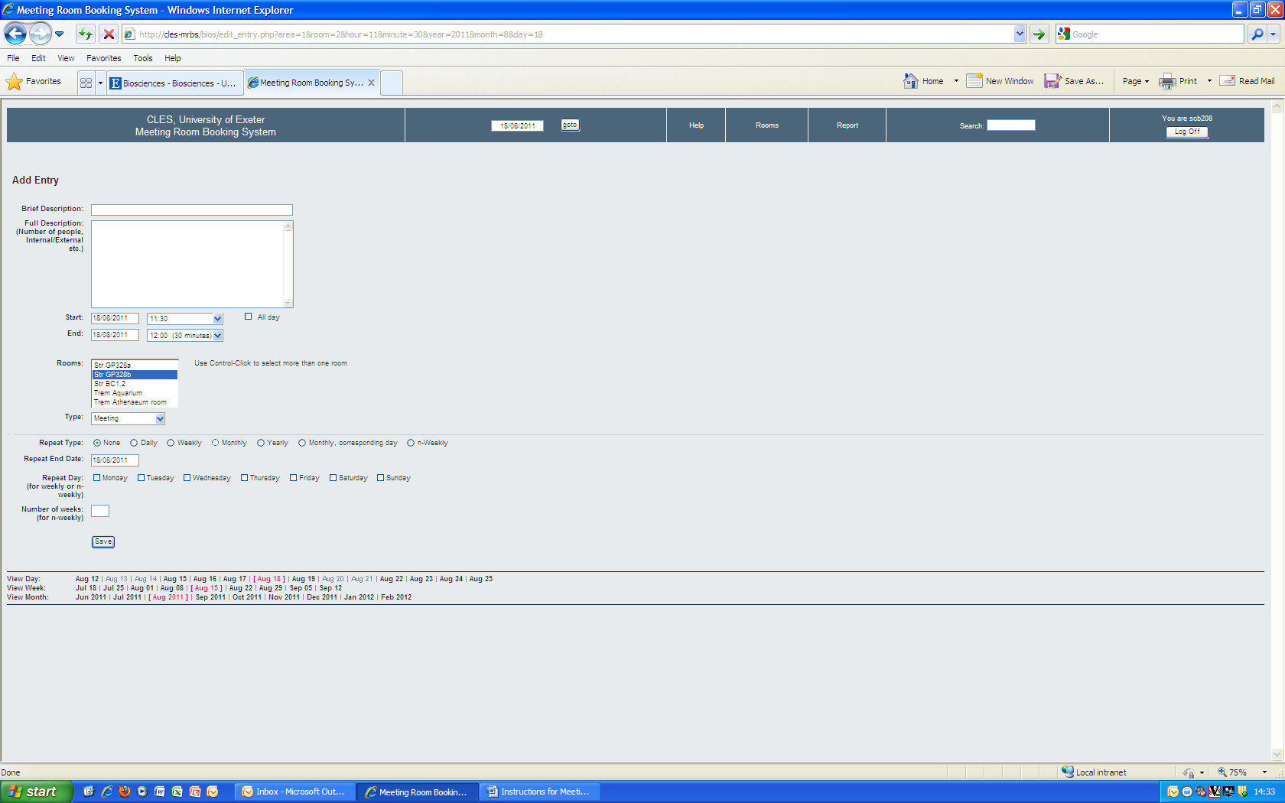

Enter the following information:

- Brief Description = title of meeting
- Full Description = how many people attending, layout of room, external/internal meeting, any other information
- Start/End = enter the start date & time + end date & time of your meeting
- Rooms = click on the room you wish to book. If you wish to book more than one room (i.e. for video conference to Streatham/Tremough or booking both of the 328 seminar rooms) then highlight first room, press Ctrl on your keyboard, then click on the other room choices
- Type = please select whether you will be using the room for video conference/presentations/both or just a meeting – so that we can ensure the correct equipment is available at the right time
- Recurring meetings = just like in Outlook you can set up a recurring meeting, so you don’t have to book the room for every month/week you want to use it. Just add in how often the meeting will recur, an end date if necessary, (and repeat day and number of weeks for weekly meetings).
- Then click Save

You will now receive an email confirming the details of your booking (you will receive one for each room you have booked – even if they are linked for the same meeting), and the meeting room booking will also automatically appear in your Outlook Calendar.

The meeting will show on the room booking sheet – with your name next to it to show who booked it – and will be colour coded depending on the type of meeting.

Edit/Delete a meeting
You may only edit or delete the meetings that you have booked.

If you wish to edit your meeting:
- Find your booking (by going to that date in the calendar)
- Click on the meeting title and you will get the screen below

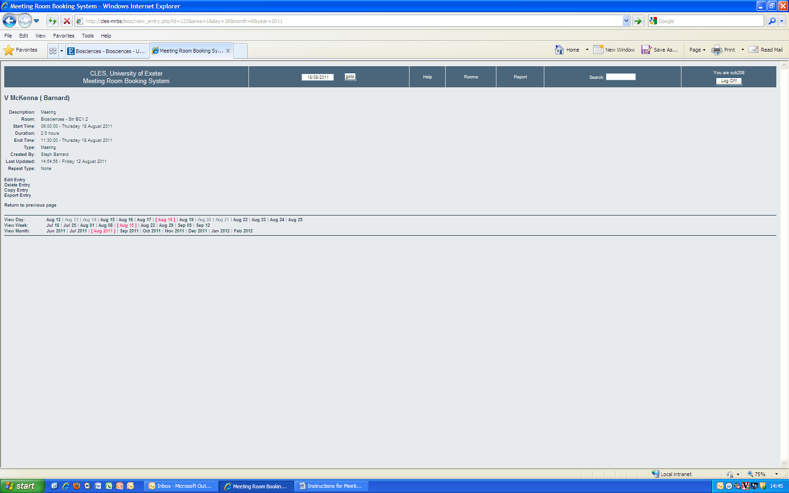

- Click on Edit Entry
- You can then change any of the details of the meeting – then click save when you have finished
- You will then receive an email confirming your changes, and it will automatically update your Outlook Calendar entry

To delete you meeting:
- Find your meeting and click on meeting title to bring up screen as per ‘edit a meeting’
- Click on Delete Entry
- You will get a pop up message asking you to confirm this – so click yes
- The meeting will then be removed from the booking system
- You will receive a ‘delete from Calendar’ notification and the meeting will be removed from your Outlook calendar

Other Options

Returning to home page
At any point in using the system, if you need to return to the main screen then click on Meeting Room Booking System at the top left of the page.
If you need to return to the University Internet at any point, without logging out, then click on CLES, University of Exeter at the top left of the page

CLES, University of Exeter
Meeting Room Booking System
Room Information
If you need to know the size/capacity of any of the rooms that are available on this system – please click on the Rooms button at the top of the page and you will be shown the screen below:
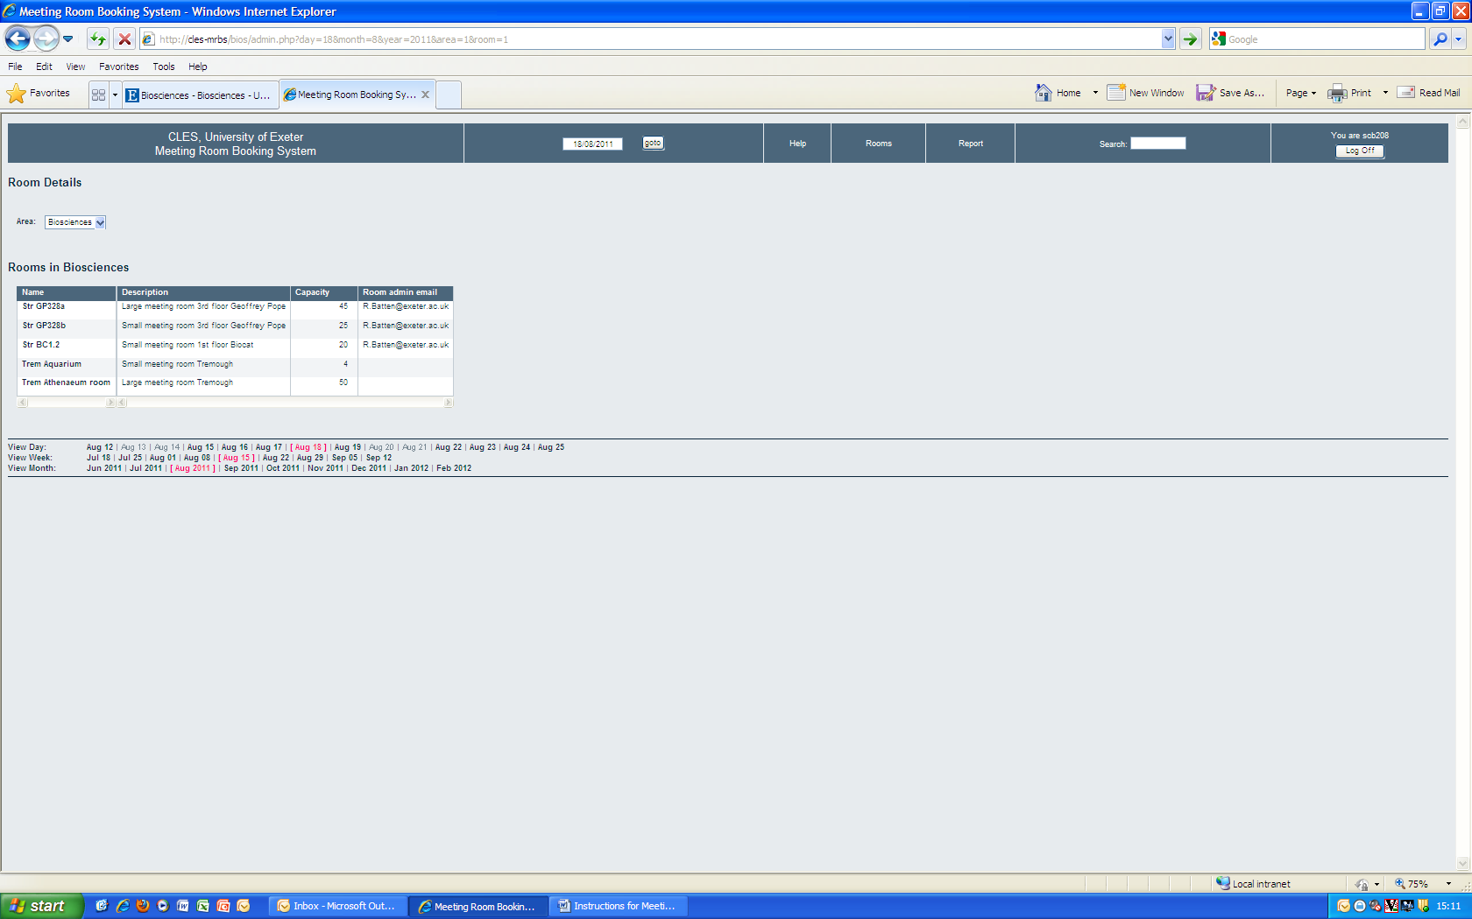
Viewing by Room
You can view availability of each room by week by clicking on the name of the room. The list of rooms will be displayed on the top left of the screen (see below) so that you can switch between rooms

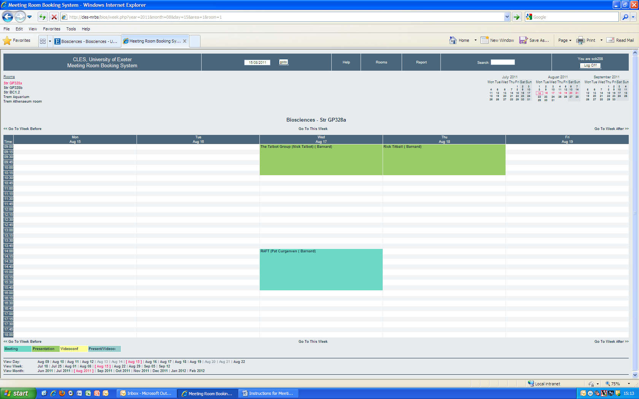

View information by day, week, month
You can change how you view the information (default setting is all rooms for one day) by clicking on the day, week or month at the bottom left of the screen

Help
There is a Help button at the top of the screen which will answer any further questions you may have about the booking system.

Further information
For any further information or assistance please contact one of the Administrators for this system, who are:

Robin Batten – 5158
Steph Barnard – 5155
Anne Walshe - 5171

